2020 Ashmore School Cross Country Carnival Country
The 2020 Ashmore Cross Country Carnival will be held on the morning of Friday 27th March (Week 9). WET WEATHER BACK UP 2nd April
Boys in each year/age group will run first followed by the girls directly after. All runners contribute points toward the overall house champion.

The approximate timeline is as follows:
9.15 Prep (approx 600m)
9.30 Year 1 (approx 600m)
9.45 Year 2 (approx 900m)
10.00 Year 3 (approx 900m)
10.15 9 Years (ALL Year 4/5 2011 born students)
10.00 10 Years (ALL Year 4/5 2010 born students)
10.45 11 years (2009 born) – from Year 4/5/6
11.00 12 years (2008 born) – from Year 5/6

11.30am House Champion announced

PRESENTATION OF MEDALS AT THE CONCLUSION OF EACH YEAR GROUP/AGE GROUP

THE TOP 5 RUNNERS FROM 2010, 2009, 2008 RACES ARE SELECTED FOR THE BROADWATER DISTRICT CROSS COUNTRY. THEY ARE ALSO ACKNOWLEDGED AT THE END OF YEAR SPORTS PRESENTATION ASSEMBLY.
Year 5 & 6
12 Years (2008 born) &
11 Years (2009 born)
Course description – (2 lap course - approx 1.5km)
Starting on far side of oval students (by the metal fence) run in a clockwise direction around oval, up steep hill at North end of Groundsman’s shed. Run around hard courts (to top of the year 2 playing area) and continue downhill following the schools northern boundary. Students follow marked course back onto oval (start/finish line). Complete again. Run around oval to finish in front of Carmichael Centre
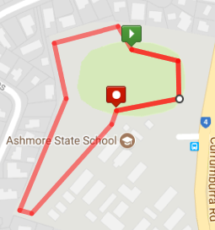
Carmichael Centre
Year 4 &/or 5
10 Years (2010 born)
9 Years (2011 born)
Course description Approx 1.2km)
Starting on far side of oval students run clockwise direction around oval, up steep hill at North end of Groundsman’s shed. Run between netball courts and bush downhill following the school boundary track back onto oval (to start line) and run around oval past finish line, up steep hill again and complete 2nd Larger loop (around hard courts). Finish in front of Carmichael Centre
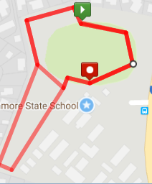

Hard Courts
Carmichael Centre
Year 2/3 Course description (Approx 900m) – (2011 born Year students run in Year 3 event)
Starting on far side of oval students run clockwise direction around oval, up steep hill at North end of Groundsman’s shed. Run around the hard courts and then downhill (northern boundary of school) following the school boundary track. Students follow marked course back onto oval and run around oval to finish in front of Carmichael Centre
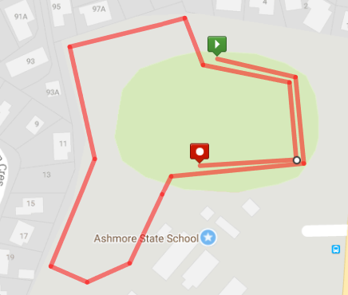
Carmichael Centre

Hard Courts

Year 1 Course description (600m approx.)
Starting on far side of oval students run clockwise direction around oval, up steep hill at North end of Groundsman’s shed. Run between netball courts and bush downhill following the school boundary track. Students follow marked course back onto oval and run around oval to finish in front of Carmichael Centre
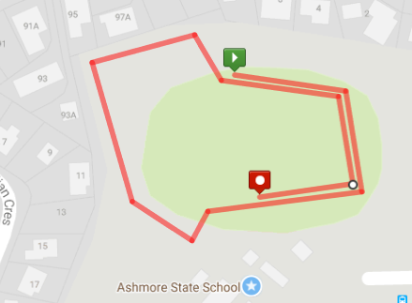
Hard Courts
Carmichael Centre

Prep Course description (600m approx.)
Starting on far side of oval students run clockwise direction around oval, up steep hill at North end of Groundsman’s shed. Run between netball courts and bush downhill. Students continue down main track onto oval. Continue around oval to finish in front of Carmichael Centre.
